Lab Report

Your Information
Your Name: Joshua Zimmerman-Gibson
Assignment Title: Business Analytics Report

Screenshots
- Load the Project_Financial_Sample.xlsx dataset Download Project_Financial_Sample.xlsx dataset into Power BI. Load the financials sheet only.
- Create a new measure called Total Units Sold, which is a DAX expression of the SUM of the units sold.
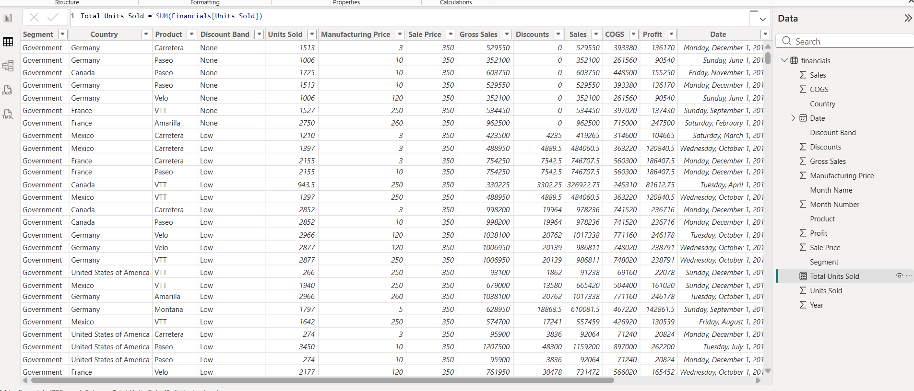
- Go to Table View and create a new table that will store a calendar table of all dates between January 1, 2013 and December 31, 2014.
  - Hint: Calendar = CALENDAR(DATE(2013,01,01),Date(2014,12,31))
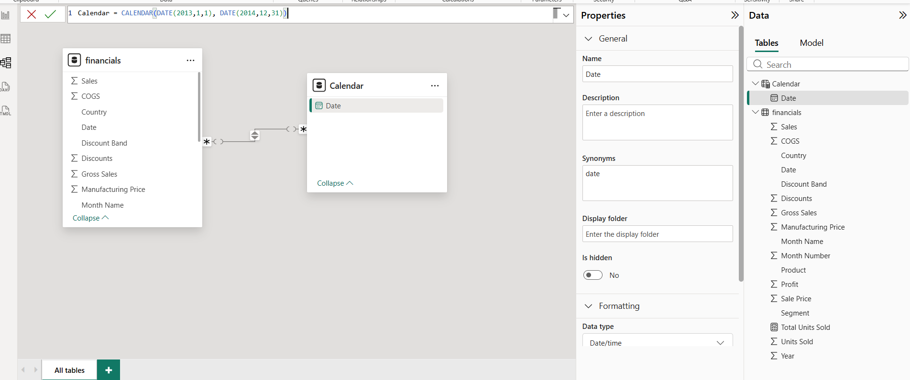
- Click on the Model View and Connect the Date field from the Financials Table to the Date field in the Calendar table.
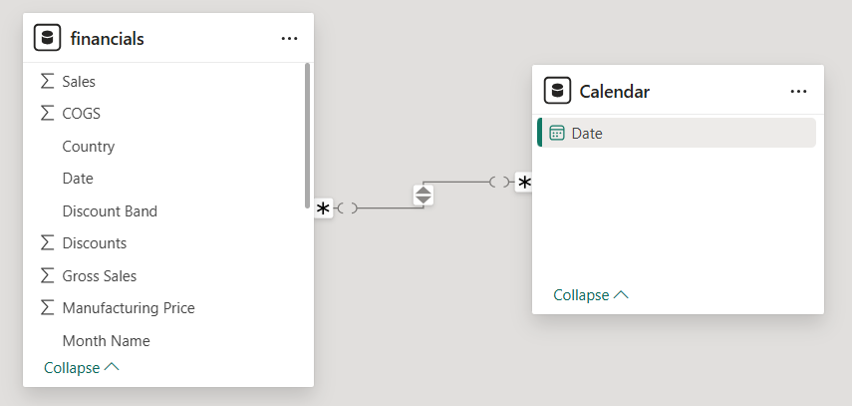
- Click back to Report View and Add a Title to your Report: Executive Summary - Finance Report (Student ID - Date). Make the font size 20 and bold the text.
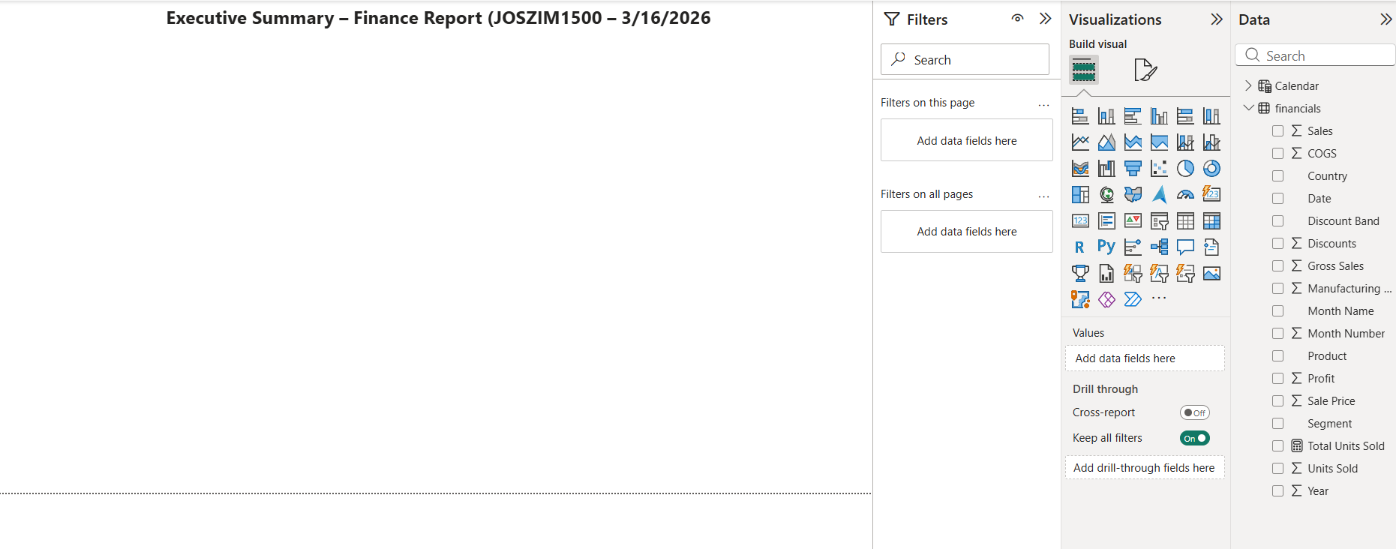
- Create the following graphs. Include your studentID and the current date in the title of each graph. Arrange the graphs so that each is easily visible on the dashboard.
  - Create a line graph that shows Profit by Date.
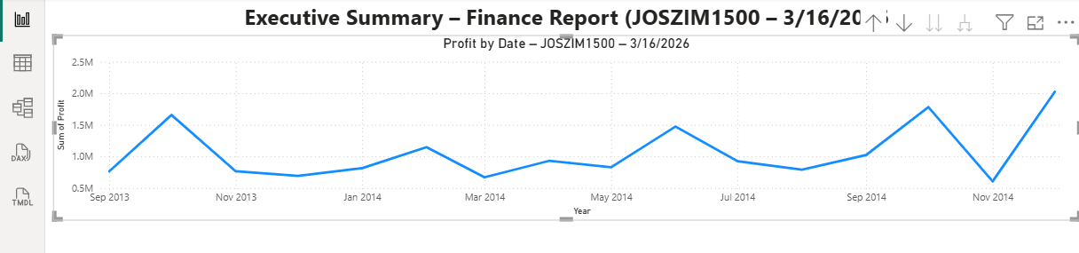
    - Create a map that shows Profit by Country.
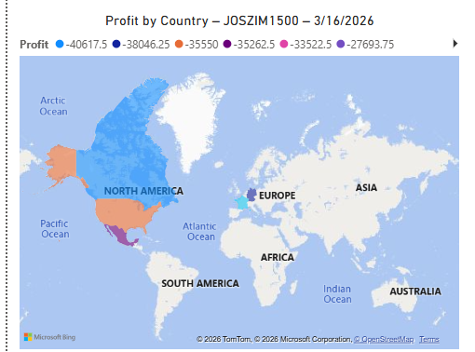
    - Create a bar chart that shows Sales by Product and Segment.
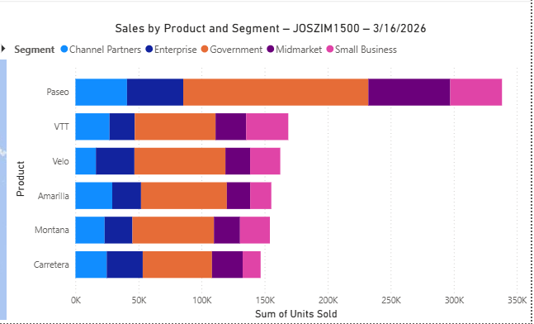
- Drag the line graph and the map so that they are side-by-side on the top half of the canvas. Drag the chart so it's wide enough to fill the entire space below the upper two charts.
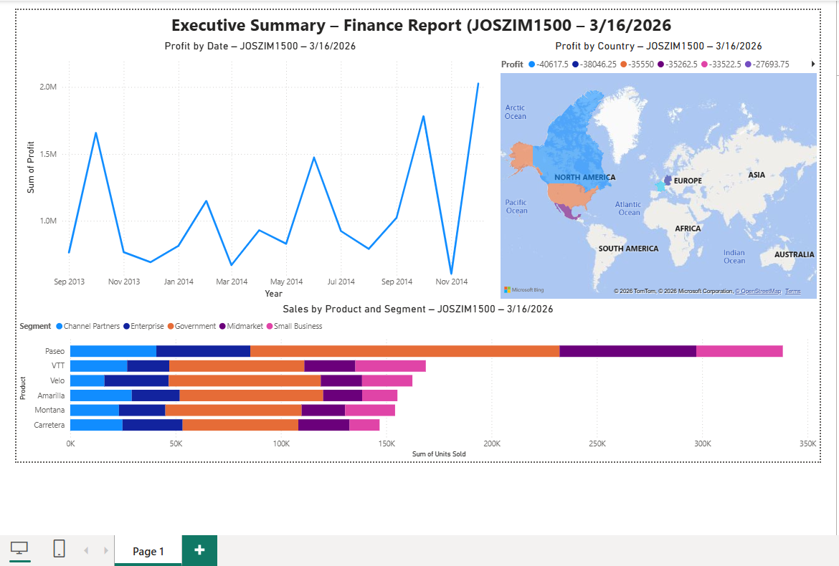
- Format the report so that it is visually pleasing.

Questions
- Which month and year had the most profit?
Q4 Dec 14, 2014 $2,025,765.90
- Which country/region is the company seeing the most success in?
France is the best at -21358.75
- Which product and segment should the company continue to invest in?

Pasio and small business ad they have the highest units sold.

